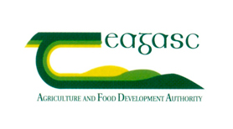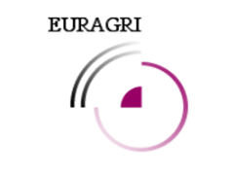
XXXI EURAGRI conference
Strategic management of agricultural and life sciences research organisations – interfaces, processes and contents
25-26 September 2017, TEAGASC Ashtown, Dublin Ireland
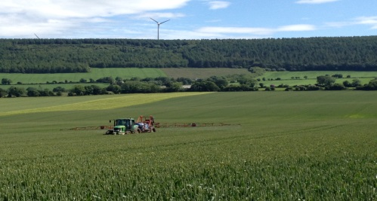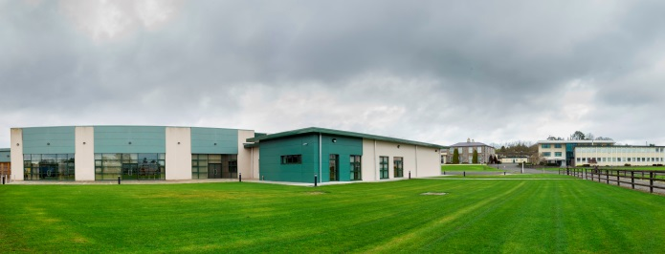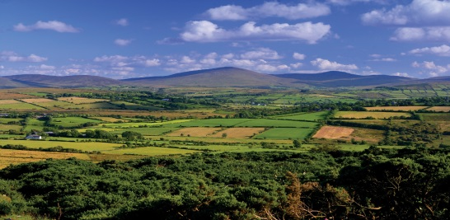
New developments - scientific, technical, societal and political - influence not only the agenda for research but also research structures, resource requirements (human and otherwise) , education and training programs and interfaces with partners and the users of research. They also have an impact on research funding and management and the way research is evaluated and monitored.
Teagasc and EURAGRI invite you to address the different dimensions of research management in the context of an evolving European research agenda. We wish to focus on the functions and challenges of research organisations concerning organisational and strategical management including planning and implementation.
We wish to discuss how changing research agendas influence what we do and how we do it. We want to create the opportunity to discuss a plurality of ideas, visions and experiences on how to execute the diverse demands and strategies. The Conference Programme should appeal to researchers, research managers, users and funders.

Monday 25 September
9:00 Welcome
TEAGASC (Gerry Boyle) and EURAGRI (Pascal Bergeret)

9:15 Challenges in the agro-food sector and rural areas – what are the expectations concerning research?
Michael Creed, Minister of Agriculture, Food and Marine, Ireland (tbc.)

9:45 Strategic management of agricultural and life sciences research organisations – interfaces, processes and contents.
Tom Richardson AgResearch, New Zealand

10:30 Coffee

11:00 Reporting from EURAGRI workshop
    - Diversity – a strategic key issue for future European agro, food and bio-economy research, Uno Svedin & Bettina Heimann EURAGRI

11:30 Panel I: Interfaces; research and interaction with different actors
Moderator: Pascal Bergeret; Director Mediterranean Agronomic Institute Montpellier

    - Private businesses Farmers: Kevin Twomey, Ireland
Firms: Cliona Murphy, Vice President, Research & Development, Pepsico
    - Authorities Local: Joe Crockett, Kilkenny County Council, Ireland
Regional: Fabio Boscaleri,Tuscany Region, Italy
    - Communities Nevena Alexandrova-Stefanova, UN FAO

12:30 Lunch

14:00 Panel II: Processes and implementation issues
Moderator: Mari Walls; President & CEO Natural Resources Institute Finland

- Programming/Managing Funding: Frank o’Mara, Director of Research TEAGASC
- Monitoring and Impact (assessment): Eliecer Lopez, IRTA, Spain
- Funding Issues: Ingrid Petersson, Director General, FORMAS, Sweden

15:00 Departure to Grange Animal and Grassland Research and Innovation Centre

17:30 Departure to hotel

18:00 General Assembly, Castleknock Hotel (members only)

19:00 Conference dinner at Castleknock Hotel

Tuesday 26 September

9:00 Post Horizon 2020
Ciaran Mangan, DG Research & Innovation, EU Commission

9:45 Panel III: Content, adaption to (complex) research agenda
Moderator: Gerry Boyle; Director TEAGASC

    - Challenge driven research: Christian Huyghe, Director Agriculture INRA, France
    - Staff skills for trans,-multi and inter disciplinary research: Nils Vagstad, Director NIBIO, Norway and Liz Elvidge, Imperial College, UK
    - Staff skills and technical development: Frank Ewert, Director, ZALF, Germany

10: 45 Coffee

11:45 Breakout sessions
- Interfaces: Moderator – Sylvia Burssens, Agrolink Vlaanderen
- Processes: Moderator – Frank o’Mara, TEAGASC
- Contents: Moderator – Christian Huyghe, INRA

13:15 Lunch

14:15 Reporting from breakout sessions

15:00 Rounding up and closing of conference (Gerry Boyle, Pascal Bergeret)

